

AI Narrative Writer: Word Template Instructions
These instructions show how to update Valcre word templates to use the new links (content controls) that support the AI narrative writer.
There are five sections detailed below: Regional Area Analysis, CMA1 Market Analysis, CMA2 Market Analysis, Commercial Rent Roll Analysis and Cap Rate: National Survey. Each section includes content controls to add into your report and instructions of the content to replace.
Additional details about the new module can be found here: Valcre-AI-Writer-Training
Replacement steps:
- Open your report document in Word.
- For each section below, select the section in your report document.
- Select the new content controls in this document and copy + paste over the section in your report document.
- Then change Linked Files on the Valcre ribbon from Base.xlsm to your appraisal workbook. Then select Update All on the Valcre ribbon to complete the sync.

Pro Tip
Turn on the paragraph marker(Windows ribbon) to easily identify where each new AI content control is located (example below).

Existing Links Where No Action Needed
Note that the links for the Key Physical Characteristics (Subject_IntroComment) and Local Area Analysis (CMA3_RecentDevComment, CMA3_UnderConstComment, & CMA3_ProposedDevComment) are preexisting within Valcre word templates, therefore, no action is needed to utilize these.

Section: Regional Area Analysis
This new content control describes historic employment trends over the past 10 years.
New Content Control
NEW cONTENT CONTROL SUPPORTED BY ai NARRATIVE WRITER
Regional_Employment_Summary

Add New Content Control as Shown Below:
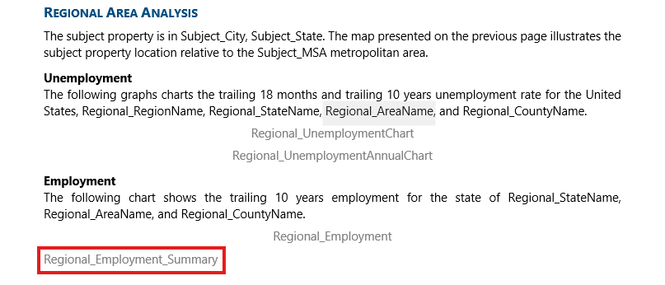

Section: CMA1 Market Analysis
There are three new AI Narrative Writer content controls for Market Analysis including:
- MA_Summary_Narrative: This new content control replaces the red text narrative blocks that explain key supply and demand statistics for the Market and Submarket.
- MA_Delivered_Narrative: This new content control provides a summary of recently delivered inventory.
- MA_Construction_Narrative: This new content control provides a summary of under construction inventory.
The following replaces the CMA1 market analysis from the Introduction paragraph through Deliveries.

MA_AnalysisType Market Analysis
In this section, market conditions which influence the subject property are analyzed. An overview of MA_AnalysisType supply and demand conditions for the Subject_Market market and Subject_Submarket submarket are presented. Key supply and demand statistics for the most recent quarter, last year and historical averages over the past MA_AnalysisDepth are summarized in the tables below.
MA_Summary
NEW cONTENT CONTROL SUPPORTED BY ai NARRATIVE WRITER
MA_Summary_Narrative

MA_AnalysisType Vacancy
The following tables provide visual illustration of the long term and short term ma_analysistype vacancy for the Subject_Market market and Subject_Submarket submarket.
MA_Vacancy

MA_AnalysisType Rental Rates
The following tables provide a visual illustration of rental ma_analysistype trends for the Subject_Market market and Subject_Submarket submarket in the short and long term:
MA_Rent

MA_AnalysisType Market Rent & Vacancy
MA_MktRentVacancy

MA_AnalysisType Deliveries
The following tables provides the recently delivered and under construction ma_analysistype supply for the Subject_Market market and Subject_Submarket submarket.
MA_Delivered
NEW cONTENT CONTROL SUPPORTED BY ai NARRATIVE WRITER
MA_Delivered_Narrative
MA_Construction
NEW cONTENT CONTROL SUPPORTED BY ai NARRATIVE WRITER
MA_Construction_Narrative

Section: CMA2 Market Analysis
There are three new AI Narrative Writer content controls Market Analysis including:
- MA2_Summary_Narrative: This new content control replaces the red text narrative blocks that explain key supply and demand statistics for the Market and Submarket.
- MA2_Delivered_Narrative: This new content control provides a summary of recently delivered inventory.
- MA2_Construction_Narrative: This new content control provides a summary of under construction inventory.
The following replaces the CMA2 market analysis from the Introduction paragraph through Deliveries.

MA2_AnalysisType Market Analysis
In this section, market conditions influencing the subject’s ma2_analysistype component are analyzed. An overview of ma2_analysistype supply and demand conditions for the Subject_Market market and Subject_Submarket submarket are presented. Key supply and demand statistics for the most recent quarter, last year and historical averages over the past MA2_AnalysisDepth are summarized in the tables below.
MA2_Summary
NEW cONTENT CONTROL SUPPORTED BY ai NARRATIVE WRITER
MA2_Summary_Narrative

MA2_AnalysisType Vacancy
The following tables provide visual illustration of the long term and short term ma2_analysistype vacancy for the Subject_Market market and Subject_Submarket submarket.
MA2_Vacancy

MA2_AnalysisType Rental Rates
The following tables provide a visual illustration of rental ma2_analysistype trends for the Subject_Market market and Subject_Submarket submarket in the short and long term:
MA2_Rent

MA2_AnalysisType Deliveries
The following tables provides the recently delivered and under construction ma2_analysistype supply for the Subject_Market market and Subject_Submarket submarket:
MA2_Delivered
NEW cONTENT CONTROL SUPPORTED BY ai NARRATIVE WRITER
MA2_Delivered_Narrative
MA2_Construction
NEW cONTENT CONTROL SUPPORTED BY ai NARRATIVE WRITER
MA2_Construction_Narrative

Section: Commercial Rent Roll Analysis
This content control replaces the red text discussion for the subject’s rent roll analysis. This is compatible with both the multi-tenant and single-tenant scenarios.

New Content Control
NEW cONTENT CONTROL SUPPORTED BY ai NARRATIVE WRITER
IA_RentRoll_Comment

Replace the Highlighted Area with New Content Control:
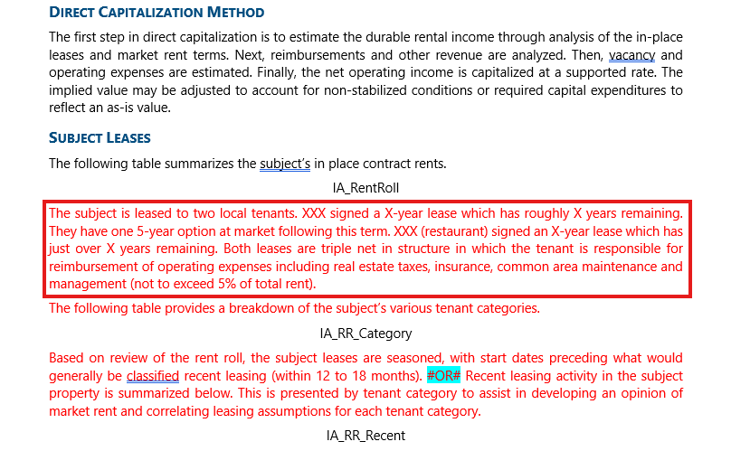

Section: Capitalization Rate - National Survey
This content control replaces the red text discussion for the PwC National Investor capitalization rate trends.

New Content Control
NEW cONTENT CONTROL SUPPORTED BY ai NARRATIVE WRITER
IA_InvestorSurvey_Comment

Replace the Highlighted Area with New Content Control:
